**A project report**

**on**

**POTATO LEAF DISEASE CLASSIFICATION USING CNN**

Submitted in partial fulfillment of the Requirement for the award of the degree of

**Bachelor of Engineering**

in

**Computer Science and Engineering**

By

S. Hemanth Reddy (1608-20-733-002)

MD. Zaki Ur Rahman (1608-20-733-048)

Under the guidance of

Mr. P Ravindra

Associate Professor



**Department of Computer Science and Engineering**

**MATRUSRI ENGINEERING COLLEGE**

**Accredited by NBA & NAAC**

**Affiliated to Osmania University, Approved by AICTE,**

**Saidabad, Hyderabad, 500059**

**2022-2023**

**MATRUSRI ENGINEERING COLLEGE**

**Accredited by NBA & NAAC**

**SAIDABAD-500059**



**Department of Computer Science and Engineering**

CERTIFICATE FROM PROJECT GUIDE

This is to certify that the project report entitled **“Potato Leaf Disease Classification Using CNN”** submitted by **S. Hemanth Reddy** bearing **H.T. No:1608-20-733-002,** **MD.Zaki Ur Rahman** bearing **H.T. No:1608-20-733-048**, in the partial fulfillment of the requirement for the award of the degree of **Bachelor of Engineering** in **Computer Science and Engineering** is a bonafide work carried by them.

The results of the investigations enclosed in this report have been verified and found satisfactory.

**Mr. P Ravindra External Examiner Dr. P. Vijaya Pal Reddy**

**Assistant Professor HOD**

**Dept. of CSE Dept. of CSE**

**MECS. MECS**

**MATRUSRI ENGINEERING COLLEGE**

**SAIDABAD - 500059**



**Department of Computer Science and Engineering**

DECLARATION

We **S.HEMANTH REDDY** bearing **H.T. No: 1608-20-733-002, MD.Zaki Ur Rahman bearing H.T. No: 1608-20-733-048** hereby certify that the mini project report entitled **“Potato Leaf Disease Classification Using CNN”** is submitted in the partial fulfillment of the requirement for the award of the degree of **Bachelor of Engineering** in **Computer Science and Engineering.**

This is a Record of bonafide work carried out by us under the guidance of **Mr P. RAvindra**, Assistant Professor, Matrusri Engineering College, Saidabad. The results embodied in this report have not been reproduced/copied from any source. The results embodied in this report have not been submitted to any other university or institute for the award of any other degree or diploma.

**S. Hemanth Reddy 1608-20-733-002**

**MD. Zaki Ur Rahman 1608-20-733-048**

**.**

**­­**

**ACKNOWLEDGEMENT**

I wish to take this opportunity to express my deep gratitude to all the people who have extended their cooperation in various ways during my mini project work. It’s my pleasure to acknowledge the help of all those individuals.

Firstly, I would like to thank **Dr. P. Vijaya Pal Reddy (HOD, DEPT OF CSE.)** for his encouragement and valuable guidance in bringing shape to dissertation.

I would like to thank my project guide, **Mr P. Ravindra** and for his guidance and help throughout the development of this project work by providing me with required information and support. Without his guidance, cooperation, and encouragement, I couldn’t learn many new things during my mini project tenure.

**ABSTRACT**

Potato farming dominates as an occupation in the agriculture domain in more than 125 countries. However, even these crops are, subjected to infections and diseases, mostly categorized into two grades: (i) Early blight and (ii) Late blight. Moreover, these diseases lead to the damage the crop and decreases its production. In this, we propose a deep learning-based approach to detect early and late blight diseases in potatoes by analyzing the visual interpretation of the leaf of several potato crops. The existing system for potato leaf disease classification relies on manual identification and diagnosis by trained professionals, which is time-consuming and prone to human error. Moreover, it is not easily scalable and requires significant resources to maintain, and the accuracy of existing system is also not pretty well.

The proposed methodology involves the use of a deep learning model trained on a large dataset of potato leaf images. The CNN architecture is optimized to achieve high accuracy and robustness in disease classification, and variations in image quality. Images are loaded by the Tensorflow dataset into batches and data augmentation is performed and the neural network is trained with images after that a website is built using react js.FastAPI and Tensorflow serving server is used for fast response, Upon uploading the image it shows the disease with confidence

**CONTENTS**

**S. No Chapter Page No**

### 1. INTRODUCTION 8-10

1.1 Objective 8

1.2 Existing System 8-9

1.3 Proposed System 9

1.4 Modules 9

1.5 Module Description 9-11

1. **LITERATURE SURVEY 12-13**
2. **METHODOLOGY OF THE PROJECT 14**

### 4. UML DIAGRAMS 15-22

|  |  |
| --- | --- |
| 4.1 Use Case Diagrams | 15-16 |
| 4.2 Activity Diagrams | 17-8 |
| 4.3 Class Diagrams | 19 |
| 4.4 State Chart Diagrams | 20 |
| 4.5 Sequence Diagrams | 21 |
| 4.6 Collaboration Diagrams | 22 |

1. **SAMPLE CODE 23-28**
2. **TECHNLOGY STACK 29-30**
3. **SCREENSHOTS 31-39**

**S. No Chapter Page No**

1. **CONCLUSIONS 40**
2. **FUTURE ENHANCEMENTS 41**

### 10. REFERENCES 42

**1. INTRODUCTION**

Potato leaf diseases pose a significant threat to the productivity and quality of potato crops, resulting in substantial financial losses for farmers. To mitigate these losses, it is crucial to develop effective methods for the early detection and classification of these diseases. One promising approach is the utilization of Convolutional Neural Networks (CNNs).

CNNs are a type of deep learning algorithm specifically designed for image analysis and classification tasks. By training a CNN model on a comprehensive dataset of labeled potato leaf disease images, the model can automatically learn and extract relevant features from the images. This feature extraction capability enables the CNN to accurately classify new and unseen potato leaf disease images into their respective disease categories. The use of CNNs for potato leaf disease classification offers a powerful tool for farmers and researchers, enabling early detection and targeted management strategies to reduce crop losses and optimize agricultural practices.

## 1.1 Objective

* To develop an accurate and efficient method for detecting and classifying different types of potato diseases based on images of potato leaves.
* To increase the speed and accuracy of potato disease diagnosis, which can help farmers make timely decisions regarding crop management and disease control.
* To improve potato crop yields and reduce economic losses due to diseases by enabling early detection and targeted treatment of potato diseases
* To contribute to the development of agriculture, which aims to optimize crop production by using technology to enhance decision-making processes.

## 1.2 Existing System

The existing system for potato leaf disease classification typically relies on manual inspection by agricultural experts or plant pathologists. These experts visually examine the leaves for symptoms and compare them with reference images or diagnostic manuals to identify the disease. However, this manual approach has several limitations and disadvantages.

**Disadvantages:**

* **Limited Expertise**: The accuracy of disease identification is dependent on the expertise and experience of the individual conducting the examination. Less common or complex diseases may be challenging to diagnose accurately, leading to increased risks of misdiagnosis and subsequent ineffective treatment.
* **Late Detection**: Manual inspection often relies on the visibility of symptoms on the leaves, which may appear late in the disease progression. By the time symptoms are visible, the disease may have already spread significantly, making it harder to control and mitigate its impact on crop yield.
* **Scalability:** As agricultural practices expand and larger areas are cultivated, the manual inspection approach may struggle to keep pace with the growing demand for disease diagnosis. The need for trained experts to inspect each plant becomes increasingly impractical and time-consuming.
* **Costly**: The requirement for skilled personnel and manual labor in disease diagnosis adds to the overall cost of agricultural operations. This cost can be burdensome, particularly for small-scale farmers who may not have the resources to employ dedicated experts for disease identification.
* **Limited Accessibility**: Access to expert knowledge and diagnostic manuals may be limited in certain regions, hindering the accurate identification of potato leaf diseases and reducing the effectiveness of disease management strategies.

## 1.3 Proposed System

The proposed system utilizes Convolutional Neural Networks (CNNs) trained on a dataset of labeled potato leaf disease images to automate and improve the accuracy of disease classification, enabling faster and more consistent identification for early detection and targeted management strategies**.**

**Advantages:**

* + - **Accuracy**: CNNs can learn and extract relevant features from images, enabling them to accurately classify potato leaf diseases with high precision, reducing the risk of misdiagnosis.
    - **Speed and Efficiency**: The automated nature of the system allows for faster disease classification compared to manual inspection, enabling early detection and timely implementation of appropriate management strategies.
    - **Scalability**: The proposed system can be easily scaled to handle large-scale agricultural operations, allowing for efficient disease classification across a wide range of plants and agricultural settings.
    - **Early Detection**: CNN-based disease classification enables the identification of diseases at early stages, even before visible symptoms appear on the leaves. This early detection facilitates prompt action to mitigate the spread and impact of diseases on crop yield.
    - **Cost-Effectiveness**: Once trained, the system can operate with minimal ongoing costs, reducing the need for continuous human involvement and potentially lowering overall operational expenses for farmers.
    - **Accessibility**: The system provides wider accessibility to accurate disease classification, as it can be deployed in various regions, regardless of the availability of expert knowledge or diagnostic manuals, improving disease management capabilities in different agricultural settings.

## 1.4 Modules

* + Data Collection and reprocessing
  + Design
  + Developing code
  + Testing and validation
  + Model training and integration
  + Front end development
  + Backend development

##### Module Description

**Module 1: Data Collection and Preprocessing**

* This module focuses on gathering a comprehensive dataset of labeled potato leaf images and performing preprocessing tasks such as resizing, cropping, and normalization to enhance the quality and consistency of the dataset.

**Module 2: Design**

* In this module, the overall system architecture and user interface design are planned and conceptualized, taking into account the requirements and objectives of the potato leaf disease classification project.

**Module 3: Developing Code**:

* This module involves the implementation of the codebase for the system, including the development of algorithms, data processing pipelines, and integration of various modules.

**Module 4: Testing and Validation**:

* This module is dedicated to testing the system for functionality, reliability, and accuracy.
* It includes the verification of individual components, integration testing, and validation against known datasets to ensure the system performs as expected.

**Module 5: Model Training and Integration**:

* This module focuses on training the CNN model using the collected and preprocessed dataset. The trained model is then integrated into the system to enable accurate disease classification.

**Module 6: Front-end Development**:

* This module is responsible for building the user interface using technologies like React, HTML, CSS, and JavaScript. It ensures a user-friendly and intuitive interface for uploading images, displaying results, and interacting with the system.

**Module 7: Backend Development**:

* This module involves developing the backend components of the system using technologies such as TensorFlow Serving and FastAPI. It handles the communication between the frontend and the deployed model, processing image data, and returning disease classification results.

**2. LITERATURE SURVEY**

**2.1: Introduction:**

In this literature survey, we explore the advancements and challenges in potato disease classification. We discuss the importance of accurate identification for effective crop management and the role of automated approaches, particularly Convolutional Neural Networks (CNNs). Analyzing relevant research papers, we examine methodologies, preprocessing techniques, model architectures, and evaluation metrics used in potato disease classification. This survey provides valuable insights for researchers and practitioners, guiding the development of improved disease classification systems in potato farming.

**2.1. Literature**

**2.2.1: Convolutional Variational Autoencoder for Potato Disease Classification**

(2020) Yan Guo, Jin Zhang, Chengxin Yin, Xiaonan Hu, Yu Zou, Zhipeng Xue, Wei Wang, "Plant Disease Identification Based on Deep Learning Algorithm in Smart Farming", Discrete Dynamics in Nature and Society, vol.2020,ArticleID2479172,11 pages,2020.https://doi.org/10.1155/2020/2479172

**Abstract:**

This study presents a novel approach to potato disease classification using a Convolutional Variational Autoencoder (CVAE). The authors collected a dataset of potato leaf images and trained the CVAE model to learn a latent representation of the input images. The model was optimized using appropriate techniques, and its performance was evaluated using accuracy metrics. The study focused on six potato diseases, including common scab and silver scurf, aiming to improve disease classification accuracy in potato crops.

**Conclusion:**

In this research, a Convolutional Variational Autoencoder (CVAE) was successfully employed for potato disease classification. The model demonstrated promising results in accurately identifying and classifying various potato diseases, including common scab and silver scurf. By training the CVAE on a dataset of potato leaf images, the model was able to learn meaningful latent representations and achieve high accuracy in disease classification. The findings of this study suggest the potential of CVAEs as a valuable tool for automated disease detection in potato crops. Further research and improvements can be explored to enhance the model's performance and extend its application to larger datasets and additional potato diseases.

**2.1.2: Potato Leaf Disease Diagnosis and Detection System Based on Convolution Neural**

**Network,** International Journal of Recent Technology and Engineering (IJRTE)**,** ISSN: 2277-3878, Volume-9 Issue-4, November 2020

**Abstract:**

This study developed a CNN-based system for potato disease detection. The authors collected a dataset of potato leaf images, preprocessed the data, trained and optimized the CNN model, and evaluated the performance using accuracy metrics. The study focused on four potato diseases, including early blight and late blight.

**Conclusion:**

In conclusion, this study successfully developed a CNN-based system for potato disease detection. By collecting a dataset of potato leaf images and preprocessing the data, the authors trained and optimized the CNN model to accurately classify four potato diseases, including early blight and late blight. The evaluation of the model's performance using accuracy metrics demonstrated its effectiveness in disease detection. The results highlight the potential of CNNs in automating and improving the accuracy of potato disease identification, which can aid farmers and agricultural experts in implementing timely and targeted management strategies. Further research could explore the extension of the system to include additional potato diseases and optimize its performance for real-world deployment.

# 3. METHODOLOGY OF THE PROJECT

**Data Collection:**

Obtain the potato leaf disease dataset from Kaggle, ensuring it includes a diverse range of labeled images representing various potato diseases and healthy leaves.

Validate the dataset, ensuring data quality and consistency.

**Data Preprocessing**:

Resize all images to a uniform resolution to maintain consistency.

Normalize pixel values to a common scale for optimal model training.

Apply additional preprocessing techniques such as cropping, rotation, or augmentation to enhance the dataset's diversity and reduce overfitting.

**Model Training:**

Select a suitable CNN architecture ,consider designing a custom architecture.

Divide the preprocessed dataset into training, validation, and test sets, typically using an 80 10-10 split. Initialize the CNN model and train it using the training set.

Optimize the model's performance using techniques like backpropagation and gradient descent, adjusting hyperparameters such as learning rate, batch size, and regularization.

Monitor the training process, keeping track of loss and accuracy metrics.

**Model Evaluation:**

Assess the trained CNN model's performance using evaluation metrics TETSUQEOUCBQ

Use the validation set to evaluate the model's ability to generalize to unseen data.

Fine-tune the model if necessary based on evaluation results.

**Frontend Development:**

Utilize React, HTML, and CSS to design and develop the frontend of the application.

Create a user-friendly interface allowing users to upload potato leaf images for disease classification.Implement features such as image preview, progress indicators, and error handling for a smooth user experience.

**Backend Development:**

Set up TensorFlow Serving, a specialized serving system, to host the trained CNN model as an API. Develop the backend using FastAPI, a Python web framework, to handle image upload requests and communicate with TensorFlow Serving.

Implement image preprocessing in the backend to ensure consistency with the training pipeline.

**Integration:**

Integrate the frontend and backend components, ensuring proper communication between them.

# 4. UML DIAGRAMS

The Unified Modeling Language (UML) is a standard language for writing software blueprints.

The UML is a language for:

* Visualizing
* Specifying
* Constructing
* Documenting the artifacts of a software intensive system.

The UML is a language which provides vocabulary and the rules for combining words in that vocabulary for the purpose of communication. A modeling language is a language whose vocabulary and the rules focus on the conceptual and physical representation of a system. Modeling yields an understanding of a system.

There are two broad categories of diagrams, and they are again divided into structural diagrams and behavioral diagrams. The structural diagrams represent the static aspect of the system. The four structural diagrams are class diagram, object diagram, component diagram, deployment diagram. Behavioral diagrams basically capture the dynamic aspect of a system. Types of behavioral diagrams are use case diagram, sequence diagram, collaboration diagram, state chart diagram, activity diagram. Some of the frequently used use case diagrams in software development are:

* + Use Case diagrams
  + Activity diagrams
  + Class diagrams
  + State Chart diagrams
  + Sequence diagrams
  + Collaboration diagrams

#### 4.1 Use case Diagram

Use case is a description of set of sequence of actions that a system performs that yields an observable result of value to actor. Actors are the entities that interact with a system. Although in most cases, actors used to represent the users of system, actors can be anything that needs to exchange information with the system. So, an actor may be people, computer hardware, other systems, etc. Use Case Diagrams for our software is shown below,

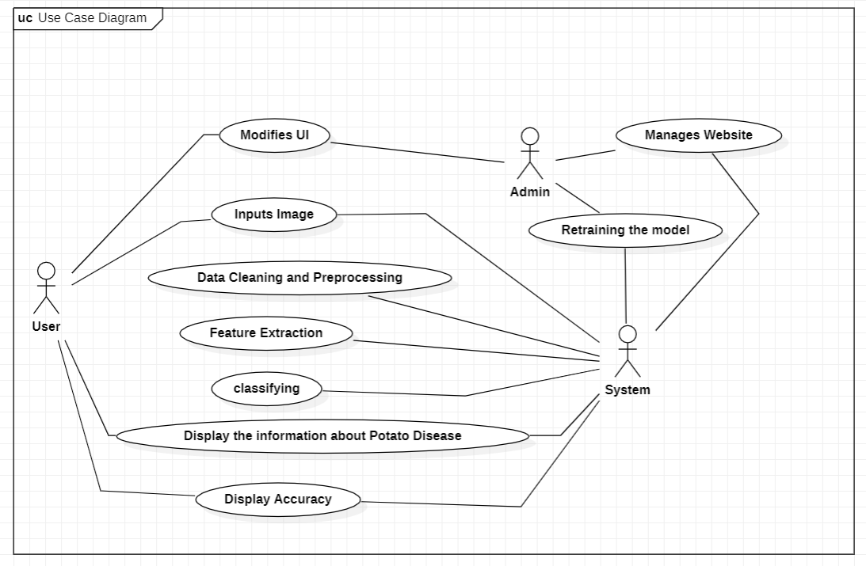

**Fig.4.1 Use Case Diagram for User User, System** **and admin.**

#### 4.2 Activity Diagram

An activity diagram is a special case of state diagram. An activity diagram is like a flow Machine showing the flow a control from one activity to another. An activity diagram is used to model dynamic aspects of the system Activities are nothing but the functions of a system. Numbers of activity diagrams are prepared to capture the entire flow in a system.

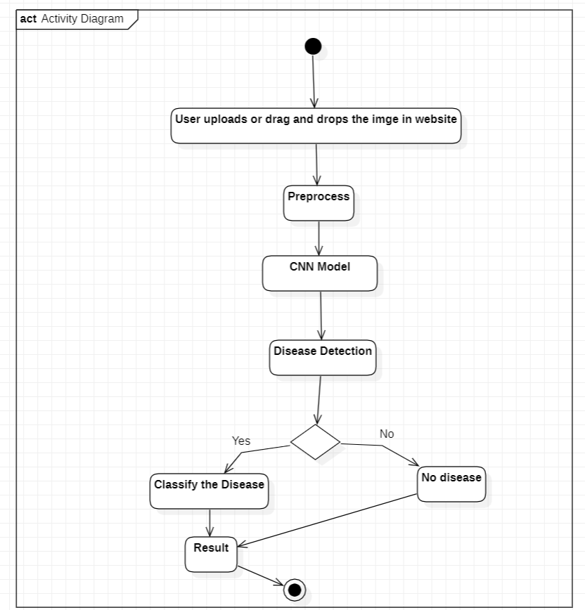

**Fig.4.3. Activity Diagram**

#### 4.3 Class Diagram

In software engineering, a class diagram in the Unified Modeling Language (UML) is a type of static structure diagram. It describes the structure of a system by showing the system's classes, their attributes, operations (or methods), and the relationships among objects.

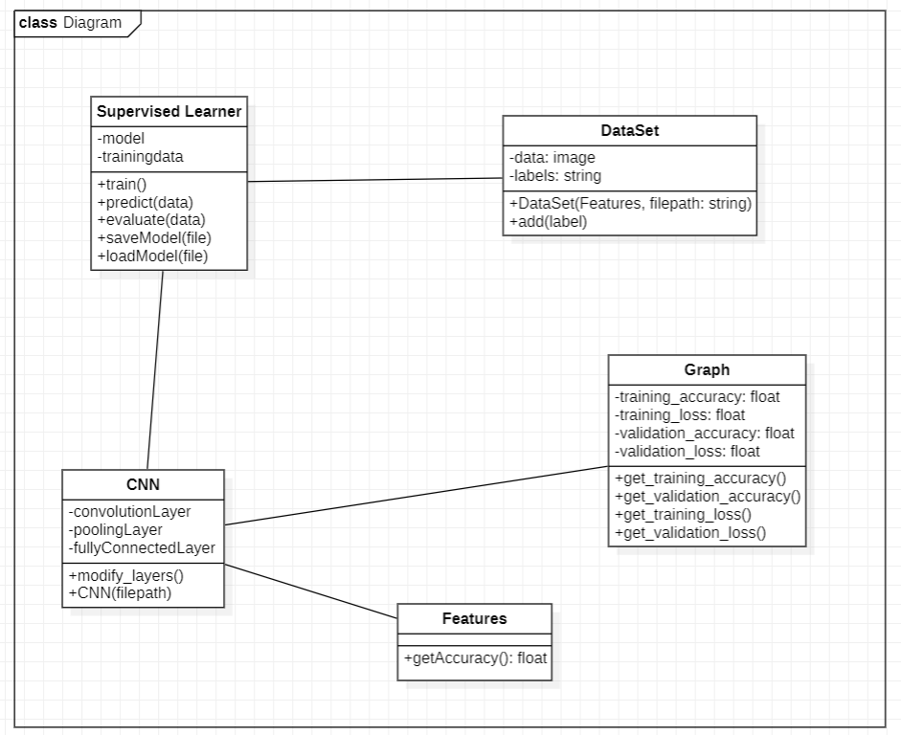

**Fig.4.5. Class Diagram.**

#### 4.5 Sequence Diagram

A sequence diagram simply depicts interaction between objects in a sequential order

i.e., the order in which these interactions take place.

Sequence diagram used lifeline which is a named element which depicts an individual participant in a sequence diagram. Communications happens as the messages appear in a sequential order on the lifeline.

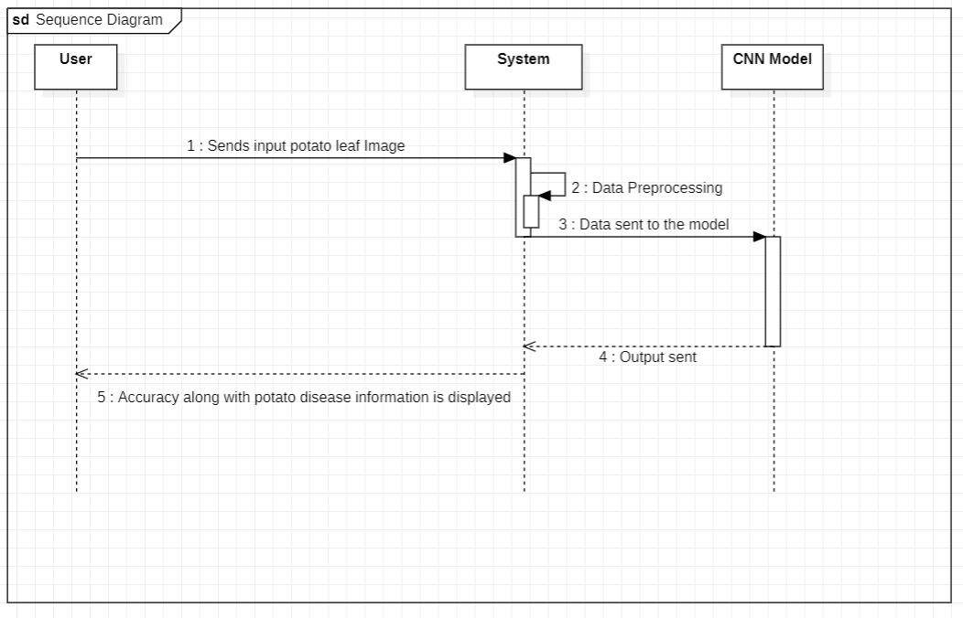**Fig.4.7. Sequence Diagram for user and system.**

### 5. SAMPLE CODE

**Model Training :** **Potato_Leaf_Disease_Classification.ipynb**

import tensorflow as tf

from tensorflow.keras import models, layers

import matplotlib.pyplot as plt

from IPython.display import HTML

BATCH_SIZE = 32

IMAGE_SIZE = 256

CHANNELS=3

EPOCHS=50

dataset = tf.keras.preprocessing.image_dataset_from_directory(

"PlantVillage",

seed=123,

shuffle=True,

image_size=(IMAGE_SIZE,IMAGE_SIZE),

batch_size=BATCH_SIZE

)

class_names = dataset.class_names

class_names

for image_batch, labels_batch in dataset.take(1):

print(image_batch.shape)

print(labels_batch.numpy())

plt.figure(figsize=(10, 10))

for image_batch, labels_batch in dataset.take(1):

for i in range(12):

ax = plt.subplot(3, 4, i + 1)

plt.imshow(image_batch[i].numpy().astype("uint8"))

plt.title(class_names[labels_batch[i]])

plt.axis("off")

len(dataset)

train_size = 0.8

len(dataset)*train_size

train_ds = dataset.take(54)

len(train_ds)

test_ds = dataset.skip(54)

len(test_ds)

val_size=0.1

len(dataset)*val_size

val_ds = test_ds.take(6)

len(val_ds)

test_ds = test_ds.skip(6)

len(test_ds)

def get_dataset_partitions_tf(ds, train_split=0.8, val_split=0.1, test_split=0.1, shuffle=True, shuffle_size=10000):

assert (train_split + test_split + val_split) == 1

ds_size = len(ds)

if shuffle:

ds = ds.shuffle(shuffle_size, seed=120

train_size = int(train_split * ds_size)

val_size = int(val_split * ds_size)

train_ds = ds.take(train_size)

val_ds = ds.skip(train_size).take(val_size)

test_ds = ds.skip(train_size).skip(val_size)

return train_ds, val_ds, test_ds

train_ds, val_ds, test_ds = get_dataset_partitions_tf(dataset)

len(train_ds)

len(val_ds)

len(test_ds)

len(val_ds)

train_ds = train_ds.cache().shuffle(1000).prefetch(buffer_size=tf.data.AUTOTUNE)

val_ds = val_ds.cache().shuffle(1000).prefetch(buffer_size=tf.data.AUTOTUNE)

test_ds = test_ds.cache().shuffle(1000).prefetch(buffer_size=tf.data.AUTOTUNE)

resize_and_rescale = tf.keras.Sequential([

layers.experimental.preprocessing.Resizing(IMAGE_SIZE, IMAGE_SIZE),

layers.experimental.preprocessing.Rescaling(1./255),

])

data_augmentation = tf.keras.Sequential([

layers.experimental.preprocessing.RandomFlip("horizontal_and_vertical"),

layers.experimental.preprocessing.RandomRotation(0.2),

])

train_ds = train_ds.map(

lambda x, y: (data_augmentation(x, training=True), y)

).prefetch(buffer_size=tf.data.AUTOTUNE)

input_shape = (BATCH_SIZE, IMAGE_SIZE, IMAGE_SIZE, CHANNELS)

n_classes = 3

model = models.Sequential([

resize_and_rescale,

layers.Conv2D(32, kernel_size = (3,3), activation='relu', input_shape=input_shape),

layers.MaxPooling2D((2, 2)),

layers.Conv2D(64, kernel_size = (3,3), activation='relu'),

layers.MaxPooling2D((2, 2)),

layers.Conv2D(64, kernel_size = (3,3), activation='relu'),

layers.MaxPooling2D((2, 2)),

layers.Conv2D(64, (3, 3), activation='relu'),

layers.MaxPooling2D((2, 2)),

layers.Conv2D(64, (3, 3), activation='relu'),

layers.MaxPooling2D((2, 2)),

layers.Conv2D(64, (3, 3), activation='relu'),

layers.MaxPooling2D((2, 2)),

layers.Flatten(),

layers.Dense(64, activation='relu'),

layers.Dense(n_classes, activation='softmax'),

])

model.build(input_shape=input_shape)

history = model.fit(

train_ds,

batch_size=BATCH_SIZE,

validation_data=val_ds,

verbose=1,

epochs=50,

)

model.save("../potatoes.h5")

**FrontEnd: home.js**

port { useState, useEffect } from "react";

import { makeStyles, withStyles } from "@material-ui/core/styles";

import AppBar from "@material-ui/core/AppBar";

import Toolbar from "@material-ui/core/Toolbar";

import Typography from "@material-ui/core/Typography";

import Avatar from "@material-ui/core/Avatar";

import Container from "@material-ui/core/Container";

import React from "react";

import Card from "@material-ui/core/Card";

import CardContent from "@material-ui/core/CardContent";

const ColorButton = withStyles((theme) => ({

root: {

color: theme.palette.getContrastText(common.white),

backgroundColor: common.white,

'&:hover': {

backgroundColor: '#ffffff7a',

},

},

}))(Button);

const axios = require("axios").default;

imageCard: {

margin: "auto",

maxWidth: 400,

height: 500,

backgroundColor: 'transparent',

boxShadow: '0px 9px 70px 0px rgb(0 0 0 / 30%) !important',

borderRadius: '15px',

},

export const ImageUpload = () => {

const classes = useStyles();

const [selectedFile, setSelectedFile] = useState();

const [preview, setPreview] = useState();

const [data, setData] = useState();

const [image, setImage] = useState(false);

const [isLoading, setIsloading] = useState(false);

let confidence = 0;

const sendFile = async () => {

if (Image) {

let formData = new FormData();

formData.append("file", selectedFile);

let res = await axios({

method: "post",

url: process.env.REACT_APP_API_URL,

data: formData,

});

if (res.status === 200) {

setData(res.data);

}

setIsloading(false);

}

}

const clearData = () => {

setData(null);

setImage(false);

setSelectedFile(null);

setPreview(null);

};

useEffect(() => {

if (!selectedFile) {

setPreview(undefined);

return;

}

const objectUrl = URL.createObjectURL(selectedFile);

setPreview(objectUrl);

}, [selectedFile]);

useEffect(() => {

if (!preview) {

return;

}

setIsloading(true);

sendFile();

}, [preview]);

const onSelectFile = (files) => {

if (!files || files.length === 0) {

setSelectedFile(undefined);

setImage(false);

setData(undefined);

return;

}

setSelectedFile(files[0]);

setData(undefined);

setImage(true);

};

if (data) {

confidence = (parseFloat(data.confidence) * 100).toFixed(2);

}

return (

<React.Fragment>

<AppBar position="static" className={classes.appbar}>

<Toolbar>

<Typography className={classes.title} variant="h6" noWrap>

SHR : Potato Disease Classification

</Typography>

<div className={classes.grow} />

<Avatar src={cblogo}></Avatar>

</Toolbar>

</AppBar>

<Container maxWidth={false} className={classes.mainContainer} disableGutters={true}>

<Grid

className={classes.gridContainer}

container

direction="row"

justifyContent="center"

alignItems="center"

spacing={2}

>

<Grid item xs={12}>

<Card className={`${classes.imageCard} ${!image ? classes.imageCardEmpty : ''}`}>

{image && <CardActionArea>

<CardMedia

className={classes.media}

image={preview}

component="image"

title="Contemplative Reptile"

/>

</CardActionArea>

}

**Backend: main.py**

from fastapi import FastAPI, File, UploadFile

from fastapi.middleware.cors import CORSMiddleware

import uvicorn

import numpy as np

from io import BytesIO

from PIL import Image

import tensorflow as tf

app = FastAPI()

origins = [

"http://localhost",

"http://localhost:3000",

]

app.add_middleware(

CORSMiddleware,

allow_origins=origins,

allow_credentials=True,

allow_methods=["*"],

allow_headers=["*"],

)

MODEL = tf.keras.models.load_model("../saved_models/1")

CLASS_NAMES = ["Early Blight", "Late Blight", "Healthy"]

@app.get("/ping")

async def ping():

return "Hello, I am alive"

def read_file_as_image(data) -> np.ndarray:

image = np.array(Image.open(BytesIO(data)))

return image

@app.post("/predict")

async def predict(

file: UploadFile = File(...)

):

image = read_file_as_image(await file.read())

img_batch = np.expand_dims(image, 0)

predictions = MODEL.predict(img_batch)

predicted_class = CLASS_NAMES[np.argmax(predictions[0])]

confidence = np.max(predictions[0])

return {

'class': predicted_class,

'confidence': float(confidence)

}

if __name__ == "__main__":

uvicorn.run(app, host='localhost', port=8000)

**main-tf-serving.py**

from fastapi import FastAPI, File, UploadFile

from fastapi.middleware.cors import CORSMiddleware

import uvicorn

import numpy as np

from io import BytesIO

from PIL import Image

import tensorflow as tf

import requests

app = FastAPI()

origins = [

"http://localhost",

"http://localhost:3000",

]

app.add_middleware(

CORSMiddleware,

allow_origins=origins,

allow_credentials=True,

allow_methods=["*"],

allow_headers=["*"],

)

endpoint = "http://localhost:8502/v1/models/potatoes_model:predict"

CLASS_NAMES = ["Early Blight", "Late Blight", "Healthy"]

@app.get("/ping")

async def ping():

return "Hello, I am alive"

def read_file_as_image(data) -> np.ndarray:

image = np.array(Image.open(BytesIO(data)))

return image

@app.post("/predict")

async def predict(

file: UploadFile = File(...)

):

image = read_file_as_image(await file.read())

img_batch = np.expand_dims(image, 0)

json_data = {

"instances": img_batch.tolist()

}

response = requests.post(endpoint, json=json_data)

prediction = np.array(response.json()["predictions"][0])

predicted_class = CLASS_NAMES[np.argmax(prediction)]

confidence = np.max(prediction)

return {

"class": predicted_class,

"confidence": float(confidence)

}

if __name__ == "__main__":

uvicorn.run(app, host='localhost', port=8000)

**6. TECHNOLOGY STACK**

**Jupyter Notebook**: Jupyter Notebook is an open-source web application that allows you to create and share documents containing live code, equations, visualizations, and narrative text. It supports multiple programming languages, including Python, and is widely used in data science and machine learning projects. Jupyter Notebook provides an interactive environment where you can write and execute code in individual cells, making it ideal for data exploration, analysis, and model development.

**React, HTML, CSS:** React is a JavaScript library for building user interfaces. It allows you to create reusable UI components and build interactive and dynamic web applications. React follows a component-based architecture, where you can define reusable components that manage their own state and update the UI efficiently. React provides a virtual DOM (Document Object Model) that optimizes rendering and updates only the necessary components, resulting in a faster and more efficient user interface. HTML is the standard markup language for creating web pages and applications. It provides the basic structure and content of a web page, defining elements such as headings, paragraphs, links, images, and more. HTML uses tags to define the structure and semantic meaning of the content, allowing web browsers to interpret and display the page correctly. CSS is a stylesheet language used to describe the presentation and styling of a web page written in HTML. It allows you to define styles for various HTML elements, such as colors, fonts, layouts, and animations. CSS separates the content and structure of a web page from its visual presentation, making it easier to maintain and update the appearance of a website.

**TensorFlow Serving**: TensorFlow Serving is a flexible serving system for deploying machine learning models in production. It allows you to serve trained TensorFlow models through a scalable and efficient API. TensorFlow Serving handles model versioning, scaling, and batching of requests, making it suitable for high-performance serving of machine learning predictions. It supports both TensorFlow models and models saved in the SavedModel format.

**FastAPI**: FastAPI is a modern, high-performance web framework for building APIs with Python. It is built on top of the Starlette framework and leverages Python's type hints to provide automatic request validation, serialization, and documentation generation. FastAPI offers high performance through the use of asynchronous programming and is compatible with popular Python libraries such as TensorFlow, PyTorch, and SQL databases. It is well-suited for developing robust and efficient backend systems that can handle high loads and provide real-time responses.

**Visual Studio Code and PyCharm**: Visual Studio Code (VS Code) and PyCharm are integrated development environments (IDEs) commonly used for coding and development. VS Code is a lightweight and versatile IDE that provides a wide range of features and extensions for various programming languages. It offers excellent support for frontend development with its rich set of tools, extensions, and integrations with web development technologies like React, HTML, and CSS. PyCharm, on the other hand, is a comprehensive IDE specifically designed for Python development. It provides advanced debugging capabilities, code analysis, and other features that enhance productivity and code quality in backend development.

**7. Testing**

**­­**

Testing is vital to the success of the system. Success testing makes a logical assumption that if all parts of the system are correct, the goal will be successfully achieved. In the process, we test the actual system in an organization and gather errors from the system that operates in full efficiency as stated. System testing is the stage of implementation, which is aimed to ensuring that the system works accurately and efficiently. The main objective of testing is to uncover errors from the system. For the uncovering process, we have to give proper input data to the system. So, we should have more conscious to give input data. It is important to give correct inputs to efficient testing. Testing is done for each module. After testing all the modules, they are integrated and testing of the final system is done with the test data, specially designed to show that the system will operate successfully in all its aspect conditions.

**7.1 UNIT TESTING:**

Unit Testing is the software testing technique where a group of software program components or modules are tested individually. This technique effectively helps in validating the accuracy of a section of code by considering stubs, mock objects, drivers and unit testing frameworks. Since it is practiced at the initial testing phase, this testing technique assures to identify and fix the bugs at the early stage of SDLC even before they become expensive for the enterprises to fix when identified at later stage. With a proper unit testing practice in place, the developers and testers can help to save time as bugs can be identified early in the process as it is the initial phase of testing. Skipping or limiting the practice of unit testing can adversely increase the defects and it becomes complex to fit them at a later stage. Hence, it is essential to practice unit testing at the initial stage of the software testing process before planning for the integration testing.

**7.2 TEST CASES**

**Test Case:- 01**

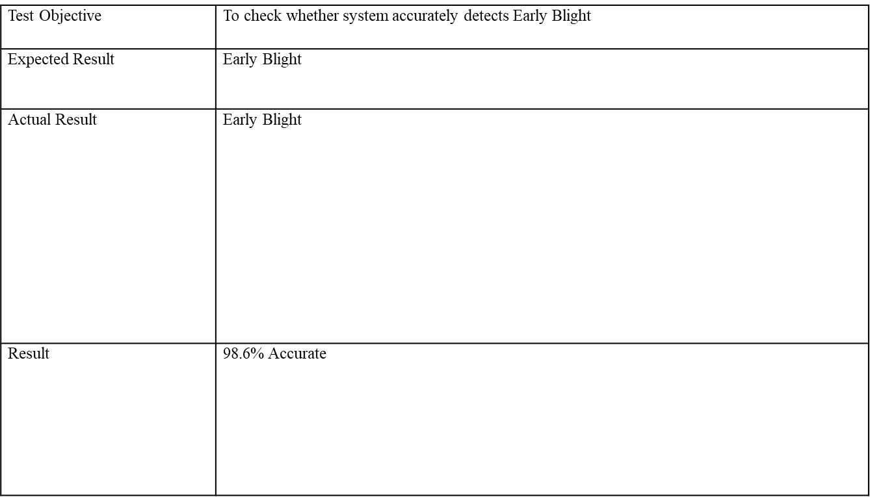

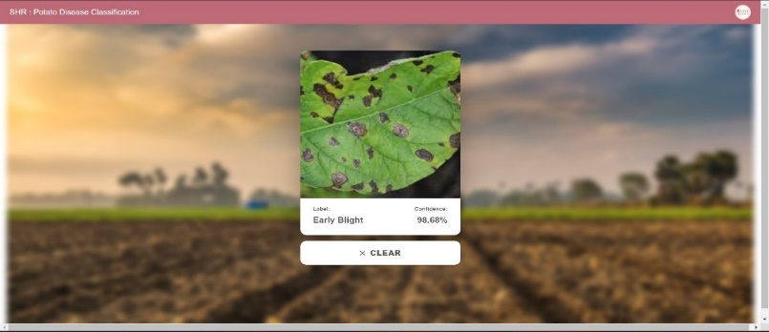

**Test Case :- 02**

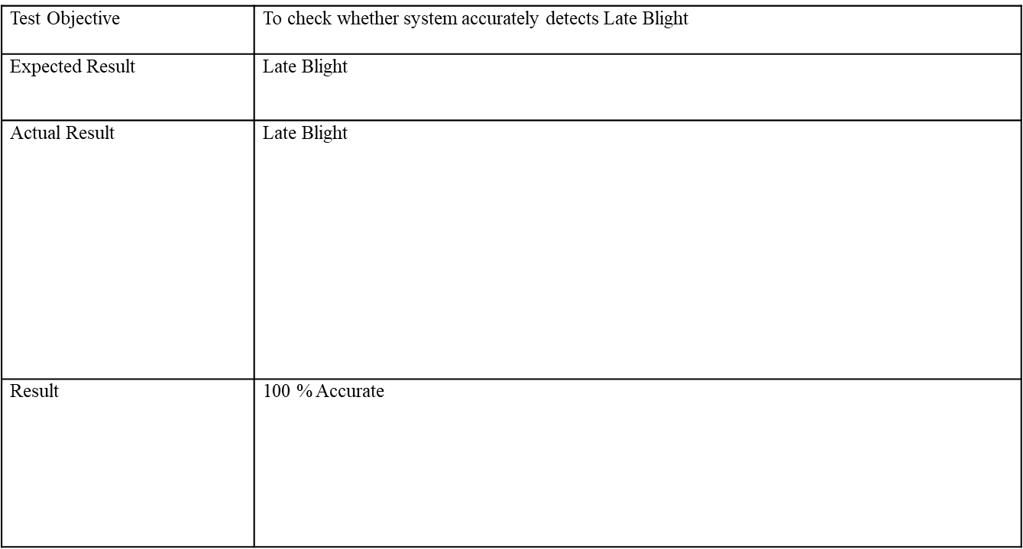

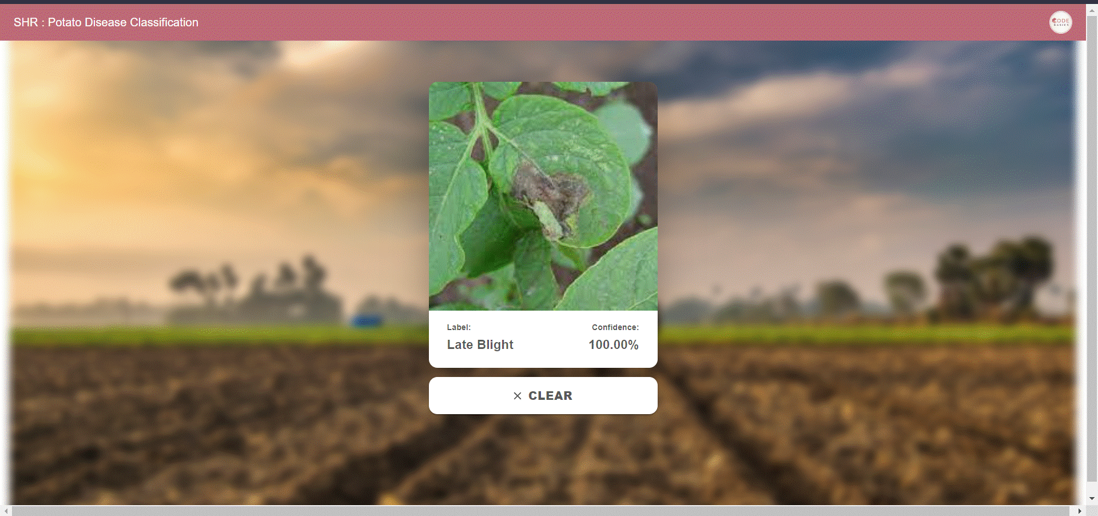

**Test Case:- 03**

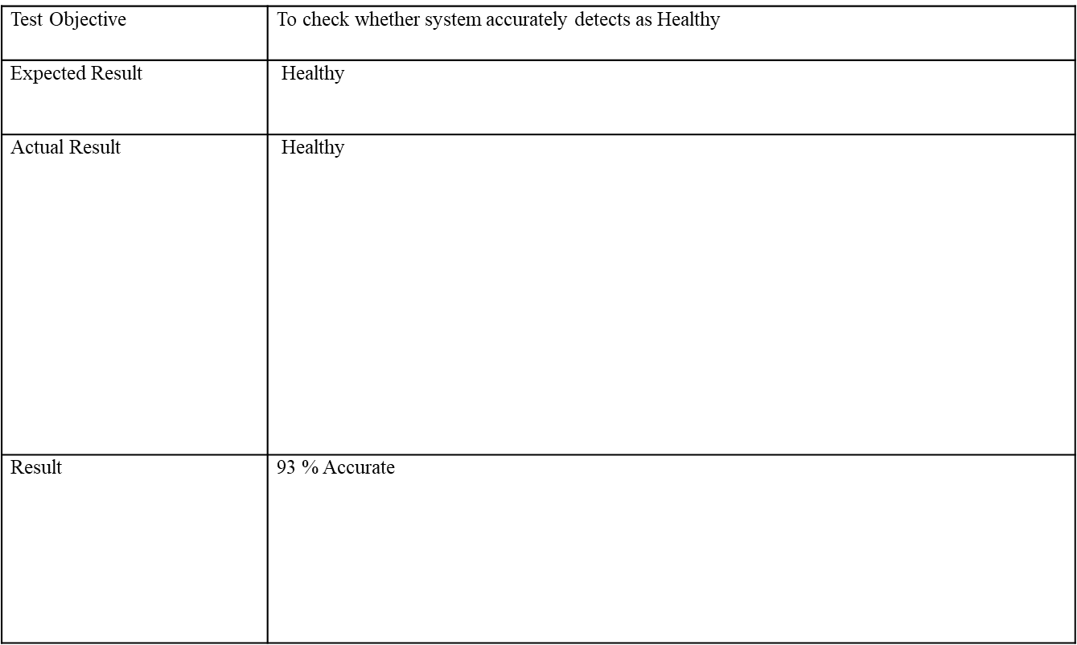

**8.RESULTS**

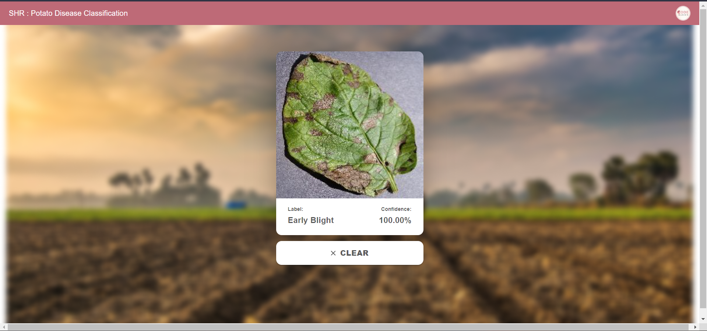

**Fig 1. Predicted Early Blight with 100% Accuracy.**

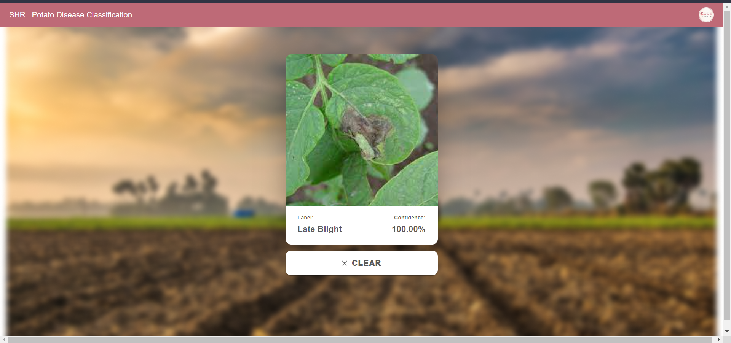

**Fig 2. Predicted Late Blight with 100% Accuracy.**

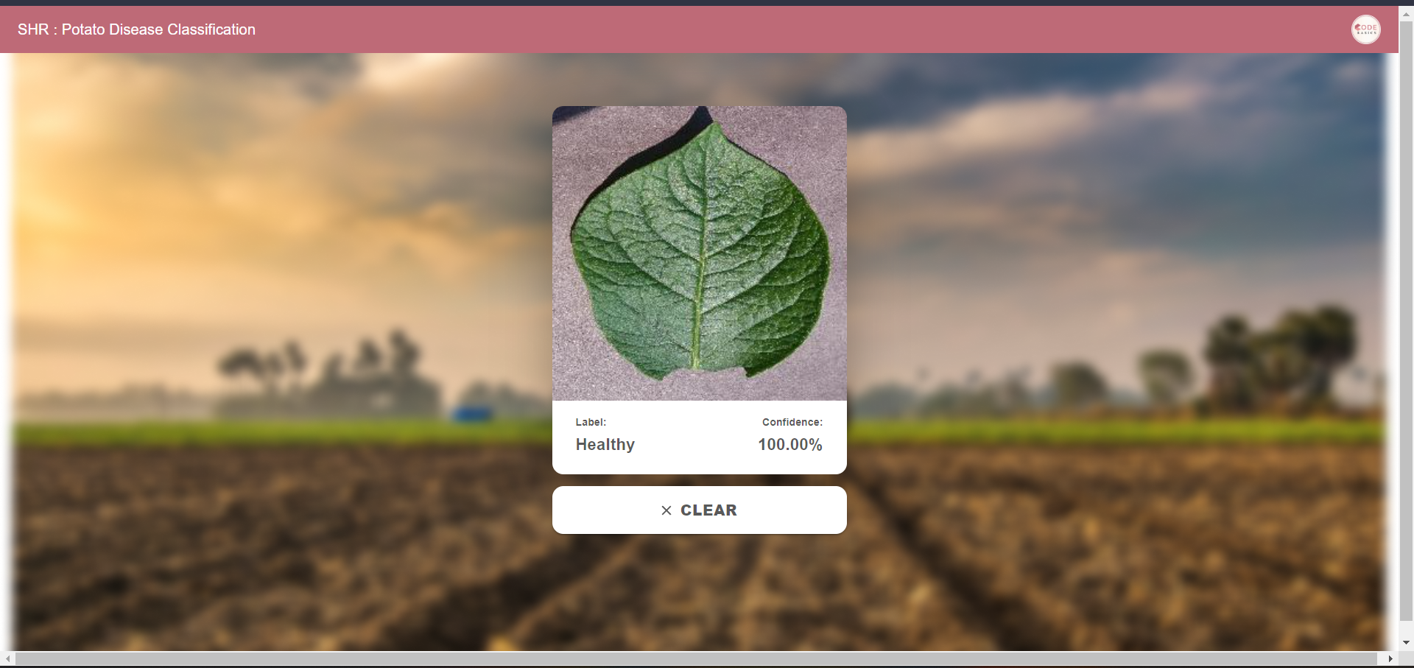

**Fig 3. Predicted as Healthy with 100% Accuracy.**

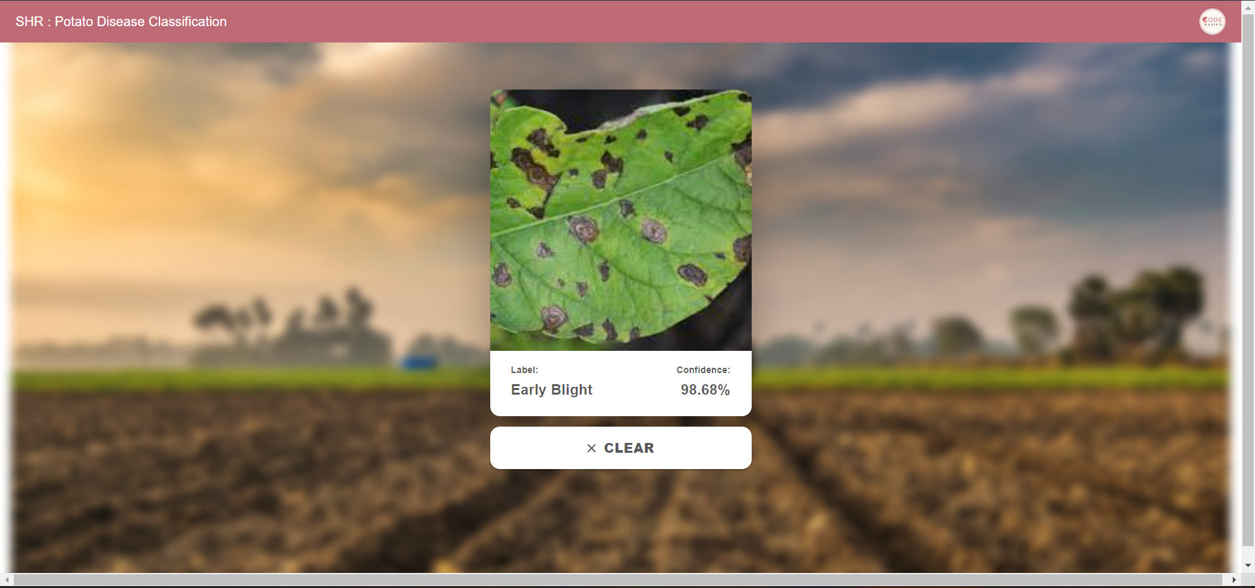

**Fig 4. Predicted as Early Blight With 98.68% Accuracy.**

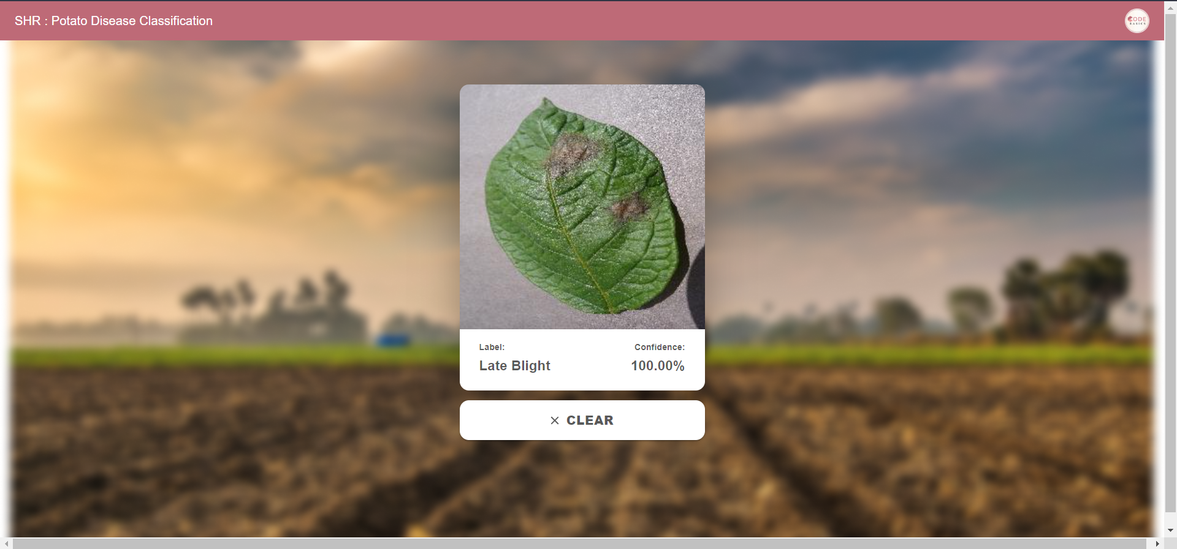

**Fig 5. Predicted as Late Blight with 100% Accuracy.**

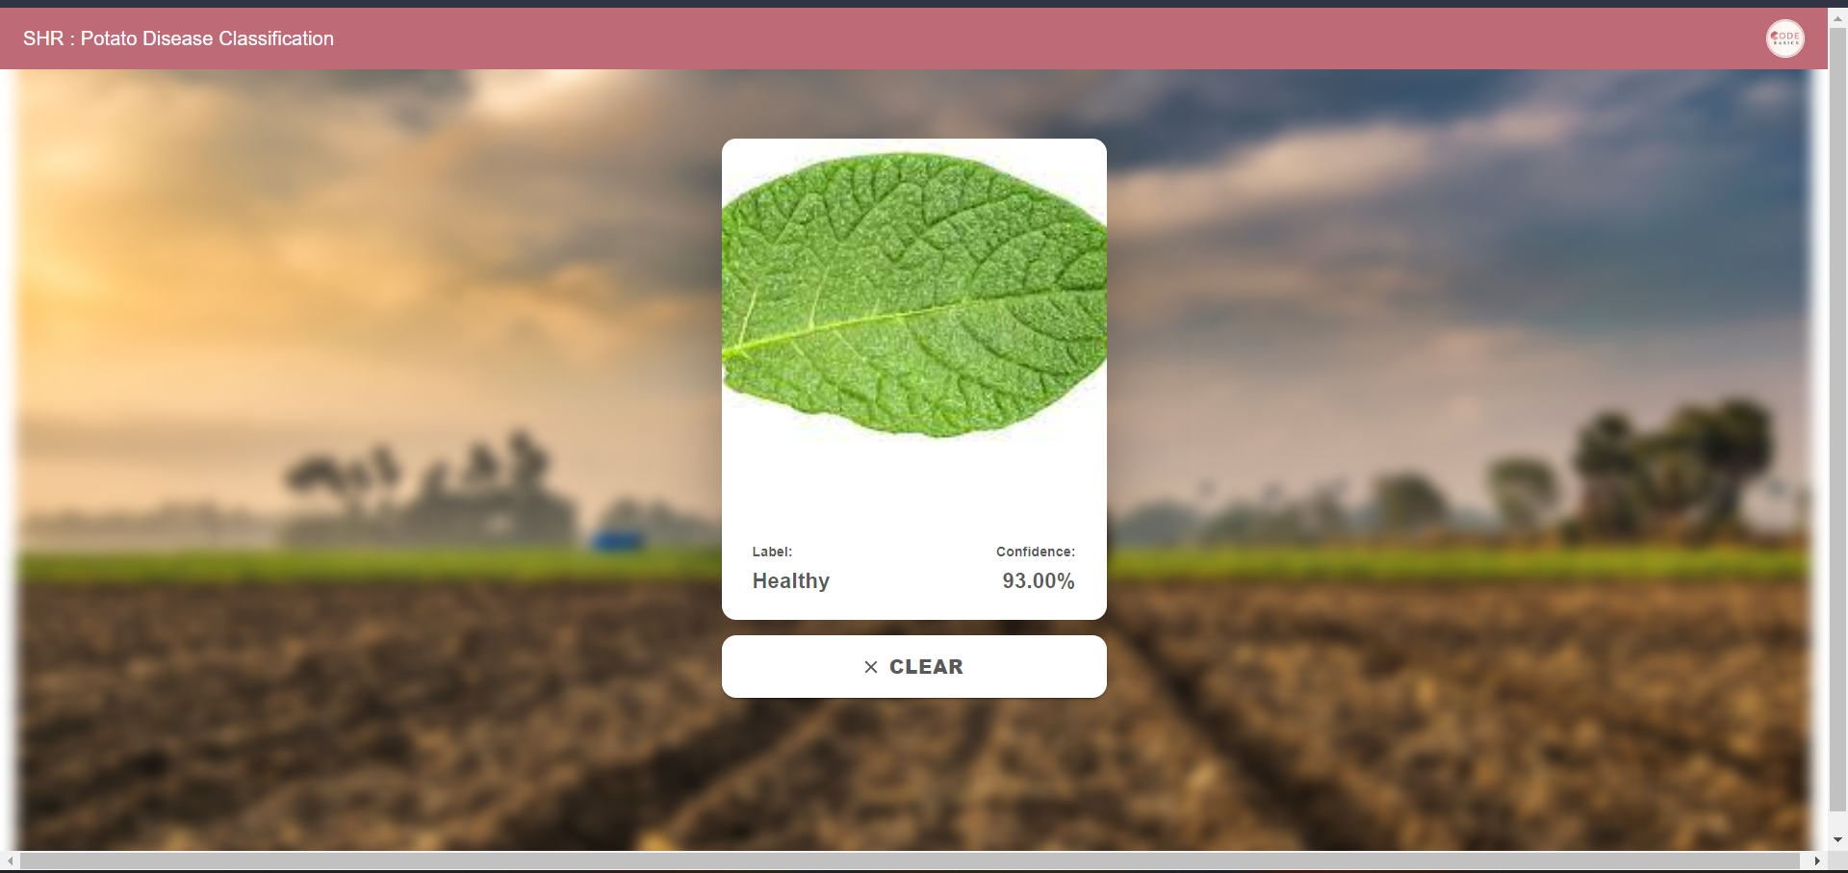

**Fig 6. Predicted as Healthy with 93% Accuracy.**

**9. CONCLUSIONS**

The implementation of a website for potato leaf disease classification using Convolutional Neural Networks (CNN) offers significant advantages in accurately identifying and classifying diseases affecting potato plants. By leveraging CNNs, which have demonstrated exceptional performance in image classification tasks, the website provides a reliable means of detecting and categorizing diseases in potato leaves. This functionality is easily accessible through the user-friendly interface of the website, allowing farmers, researchers, and stakeholders to conveniently upload images of potato leaves and receive immediate disease classification results. Moreover, hosting the classification system as a website ensures its widespread accessibility, enabling users to access the system from any device with an internet connection. The scalability of the website allows it to handle multiple requests simultaneously, accommodating a larger user base. This visual information aids in decision-making processes and enhances the comprehension of disease severity and distribution within potato crops. Beyond disease classification, the website can serve as an educational resource by providing information on different potato leaf diseases, their symptoms, and recommended treatments, empowering users to make informed decisions regarding plant health. Furthermore, the website's implementation enables continuous improvement of the underlying CNN model, as updates and enhancements can be easily integrated to keep pace with the latest advancements in machine learning and the availability of new data. Overall, the website for potato leaf disease classification using CNNs presents a valuable tool for stakeholders in potato cultivation, research, and plant health management, contributing to the sustainability and productivity of potato crops.

**9. FUTURE ENHANCEMENTS**

* IoT Integration: Integrate with plant health monitoring devices for real-time disease detection.
* Mobile Application Development: Create a mobile app for convenient image uploads and classification.
* Multi-Language Support: Provide translations and local language options for broader accessibility.
* Collaboration and Knowledge Sharing: Build a platform for users to share images, contribute data, and engage in discussions.

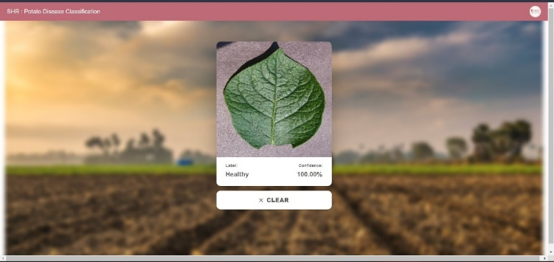

**10. REFERENCES**

* Zhang, Y., Zhao, Z., Liu, Y., & Sun, Y. (2020). Deep learning-based potato disease recognition system. In International Conference on Industrial, Engineering and Other Applications of Applied Intelligent Systems (pp. 161-170). Springer, Cham.
* Pal, M., & Maiti, R. (2020). A review on disease detection of potato using machine learning techniques. International Journal of Emerging Trends in Engineering Research, 8(9), 3572-3577.
* Abdelaziz, S., El-Shishtawy, T., & Aleisa, E. (2018). Potato disease detection based on convolutional neural networks. Sensors, 18(5), 1545.
* Yang, Y., Lu, H., Wen, Y., & Cao, Y. (2021). Potato disease identification based on deep learning technology. Journal of Physics: Conference Series, 1831(1),012001.
* Tiwari D, Ashish M, Gangwar N, Sharma A, Patel S, Bhardwaj S. Potato leaf diseases detection using deep learning. In2020 4th International Conference on Intelligent Computing and Control Systems (ICICCS) 2020 May 13 (pp. 461-466). IEEE.

­­